A482-AM,N-NW-Tlingit-Wolf-Mask-Shaman-19th cent

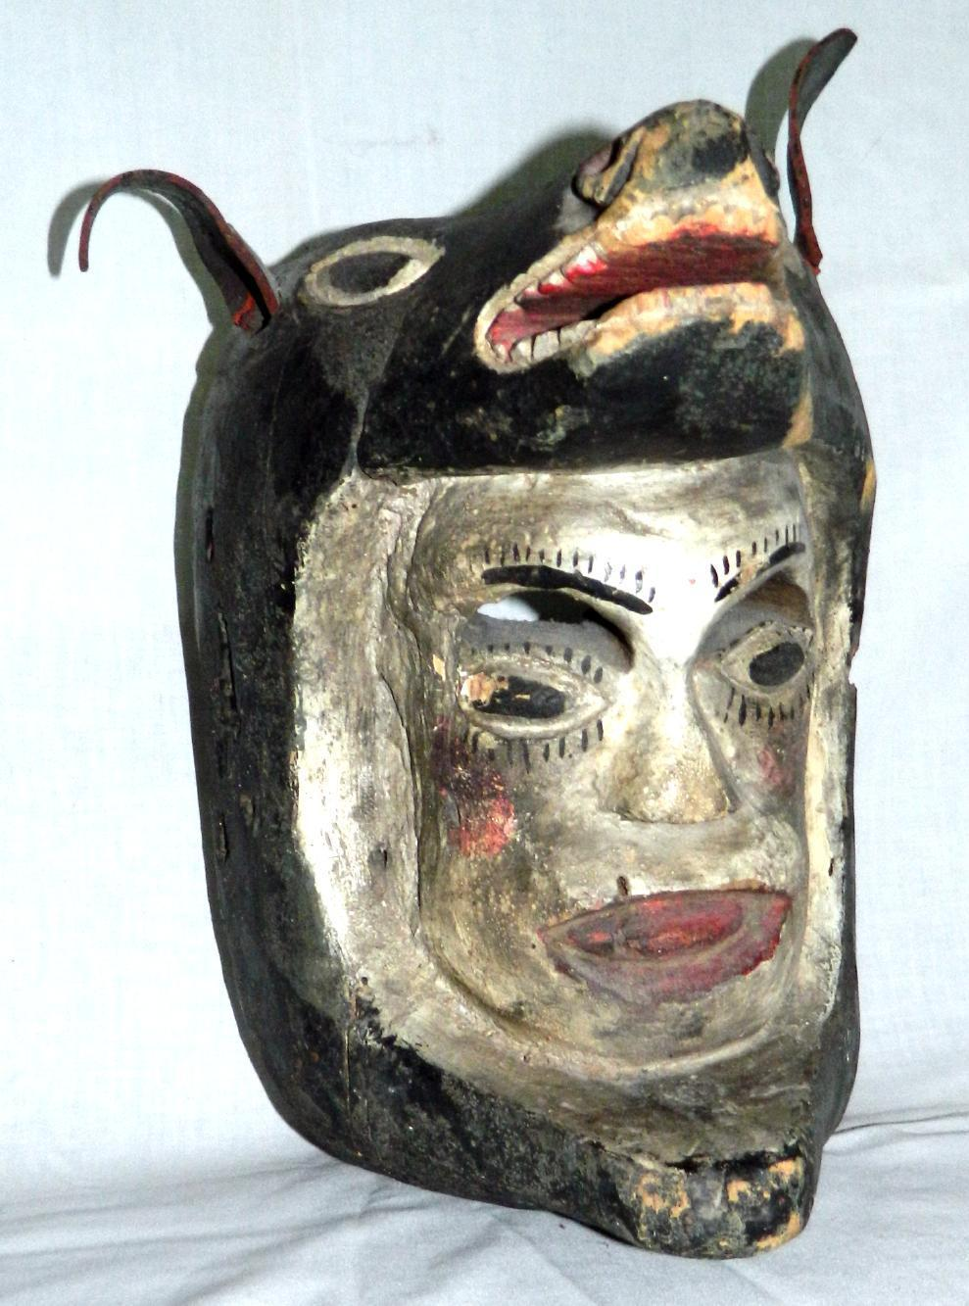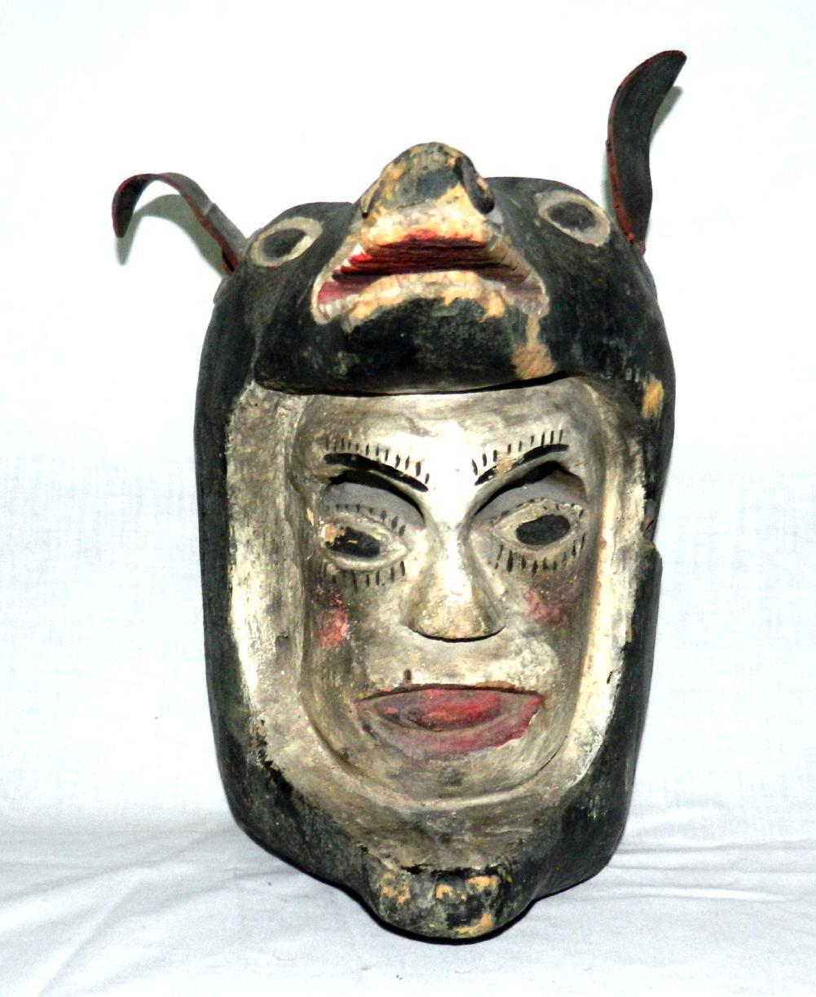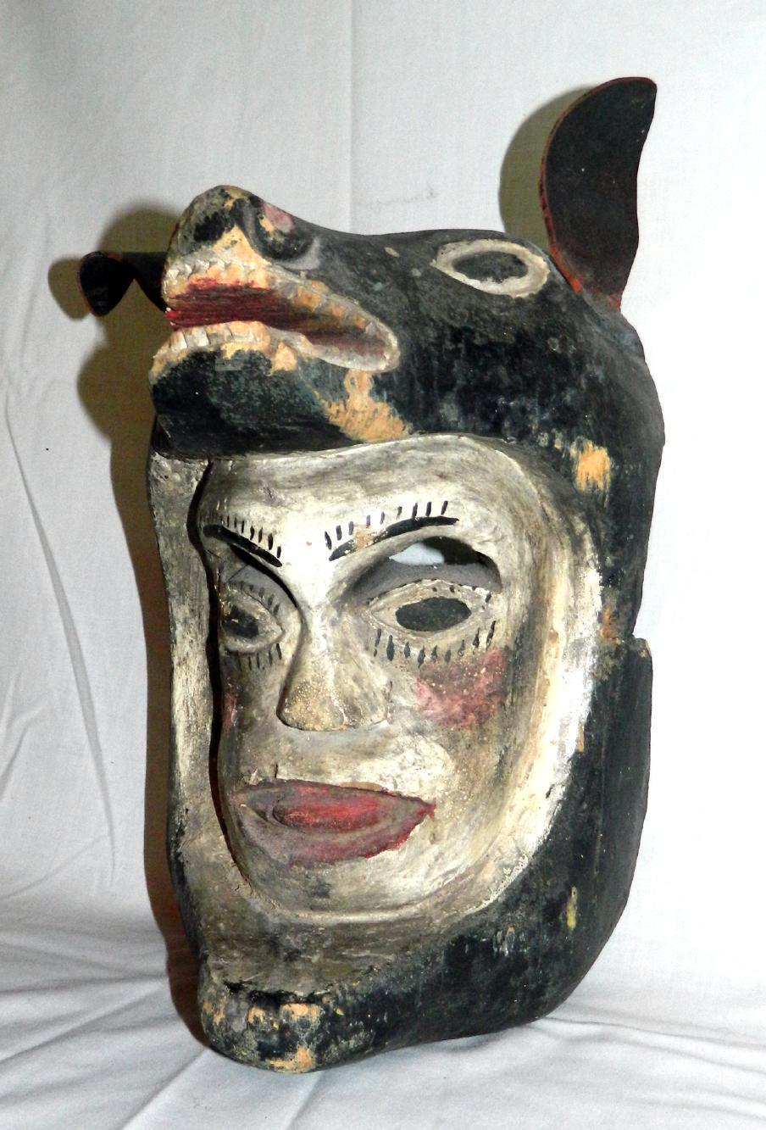

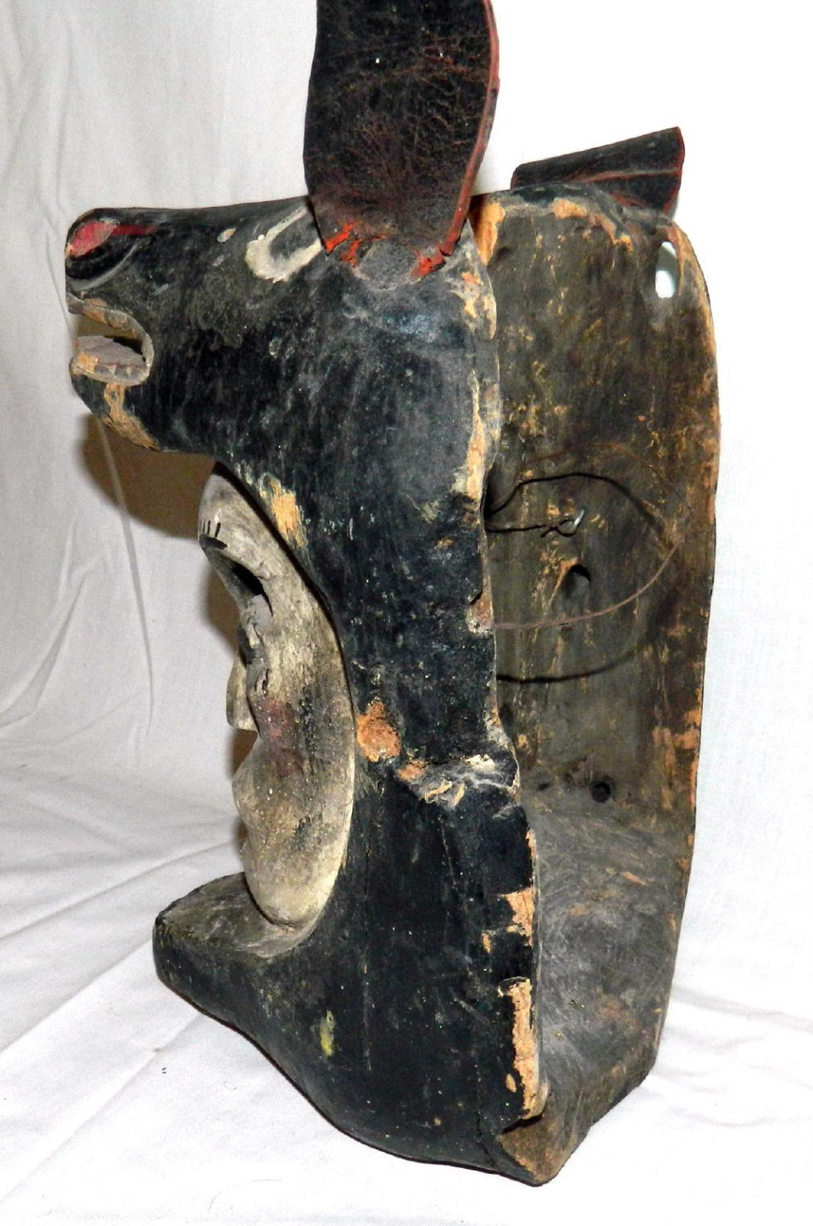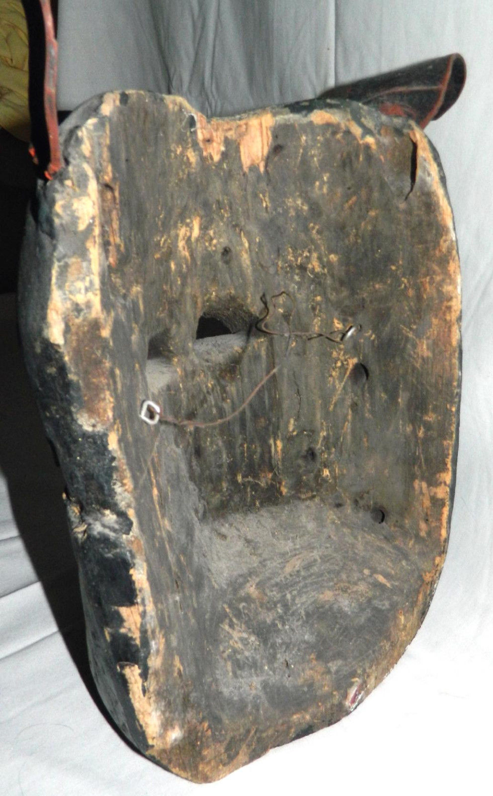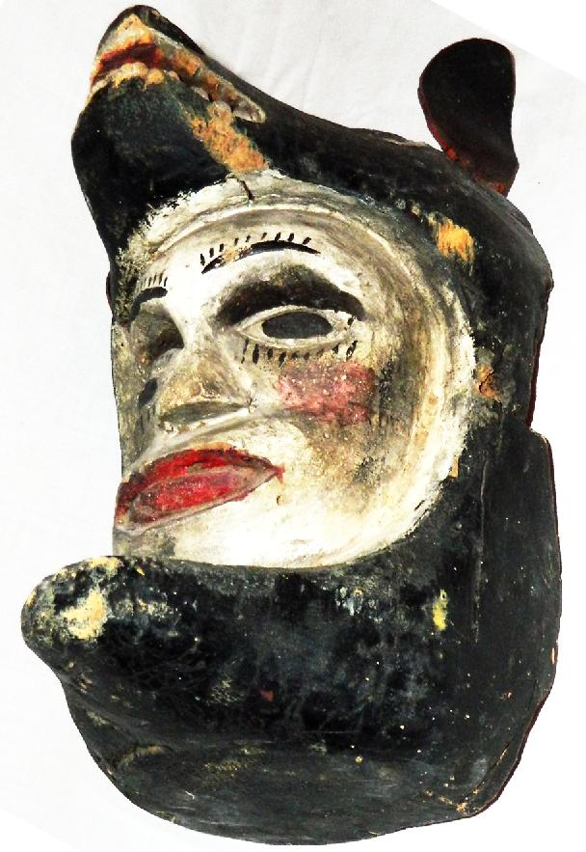

Figs. 1-6. Tlingit-Wolf-Mask-Shaman-19th cent.

Case no.: 8

Formal Label: Tlingit-Wolf-Mask-Shaman-19th cent

**Display Description:**

This mask proffers a dying man’s face, identified by its white pigment and its open mouth, as it is being engulfed by a wolf’s open jaws. However, the individual is not physically dying in this iconography but dying to his mortal self and, in the process, he is spiritually assimilating the being and power of the wolf spirit.

Similar images can be found in many prehistoric cultures where the shamanic impulse is to meld with the powers of nature in all its aspects to solve human problems. This is how the shaman is distinguished from the priest who acts as a functionary of an institution with established dogma or guidelines, while the shaman acts through his own *experiential* spiritual insights which may change without notice as new experiences are added to his repertoire.

Accession Number: A482

LC Classification: E99.T6

Date or Time Horizon: 19th century

Geographical Area: Northwest Coast

Cultural Affiliation: Tlingit

Medium: White pine wood, animal hide, black, red and white pigment.

Dimensions: H 7.62 cm, 15.5 inWeight: 659 gm, 1 lb, 7 1/8 oz

Provenance: unknown

**Condition:** original

**Discussion:**

A Tlingit myth recalls that a hunter who physically died at sea became an orca and a hunter who died on the hunt became a wolf (Wardwell 2009). These are extreme examples of the transformation of an individual into an animal helper in a crisis moment. The point is, however, that one need not physically die to *experience* such melding with the being of an animal helper. The orca in this myth became a sacred being for the fisherman, while the wolf became a sacred being for the hunter. New ontologies were being born. A prohibition emerged among the Tlingit against killing both the orca and the wolf. These prohibitions were on the way to becoming cultic. One of the first steps toward institutionalization is to provide guidelines of behavior for those who have not had similar *experiences*. Hence an institutional functionary *could lack the critical experiences* that started a cultic movement but adequately perform the duties required by nominally following the guidelines. This mask visually argues against following such a path. It says experience of being in the wolf’s mouth is everything. Without it one has no experience of what it is to be a wolf or to use the power of a wolf (Curtis 1970 [1907-1930], 10:36). Compare with Metropolitan Museum of Fine Art 1979.206.440, The Michael C. Rockefeller Collection, bequest of Nelson A. Rockefeller, 1979 (Wardwell: 2009: 147, fig. 157).

**References:**

Curtis, Edward Sheriff. 1970; [i.e., 1907-1930]. *The North American Indian*. New York: Johnson Reprint. 10 vols.

Wardwell, Allen. 2009. *Tangible visions: Northwest Coast Indian Shamanism and its art*. New York: Monacelli Press.